CSE 6010 Assignment 2 Version 2 1st Part

Dawei Geng

1. I created a new priority queue with a heap data structure, it could be run with the original simulation engine. Then I wrote a simple test program to test the priority queue. I initiate N events in the priority queue, and each time, create a for loop, in which I delete and add an event to the queue, then loop lots of times to see how long it takes to handle these events in terms of the number of events processed per second. Then I run the test program with original priority queue with linked list. I compared their performance in a graph. See below.
2. Big O analysis:

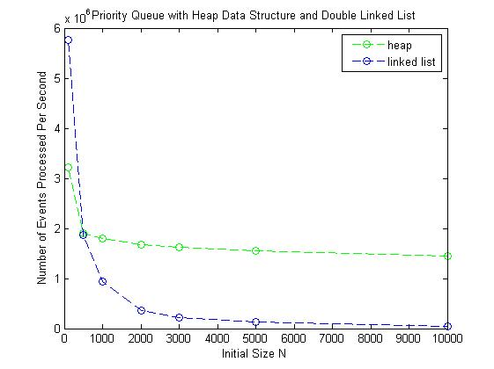

The result is consistent with what I expect from Big-O analysis, linked list takes linear time O(n), while heap takes log time O(log(n)). As we could see from the plot, when n is small, linked list is faster than the heap structure, while as the n get bigger, we could see heap is much faster than the linked list.

CSE 6010 Assignment 2 Version 2 2nd Part

Will Tse-Wei Fu #903136885

1. We use following criteria to determine which aircraft gets to use the runway:
   1. Landing event gets the highest priority
   2. When runway is busy, put the departure event put into a FIFO queue.
   3. The aircraft will need to re-enter the FIFO queue if the time it was scheduled beforehand happened to have a busy runway.
2. We run the simulation 30 times to and record the following waiting time data.
   1. It is not surprised to find out that the difference between average waiting time for Version 1 and Version 2 is very small since we give the landing event the highest priority in the latter version.
   2. We have recorded the aircraft id in the simulation program. And it turns out that sometimes the aircraft needs to re-enter the FIFO queue, and thus the waiting time to depart for the particular aircraft gets substantially longer, which increases the average waiting time to depart.

